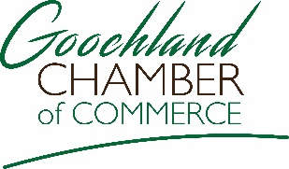

2931 River Road West, P.O. Box 123, Goochland, VA 23063
(804) 556-3811 www.goochlandchamber.org

Professional Opportunity

The Goochland County Chamber of Commerce is seeking an Executive Director

The Executive Director is responsible for managing the operational aspects of the chamber in alignment with the chamber By-laws at the direction of the board of directors. This role serves a critical chamber function of actively engaging existing and prospective members to promote the role of the chamber and to continually seek new ways to advance the chambers mission in Goochland County. Our chamber supports the business community, through business development and membership success. Goochland County is a growing community with business expansion. We are a suburb of Richmond, Virginia that offers a mixture of the suburban and rural communities.
You can learn more about our county and chamber at http://goochlandva.us
http://goochlandchamber.org

This is a fulltime position and applications are being accepted immediately.

Interested parties can email a Letter of Interest and Resume to officeadmin@goochlandchamber.org

